**Aim:** To implement Single Source Shortest Path using Greedy Approach (Dijkstra)

**Theory:** Dijkstra's algorithm allows us to find the shortest path between any two vertices of a graph. It differs from the minimum spanning tree because the shortest distance between two vertices might not include all the vertices of the graph.

The algorithm uses a greedy approach in the sense that we find the next best solution hoping that the end result is the best solution for the whole problem.

**Example:** For a given graph

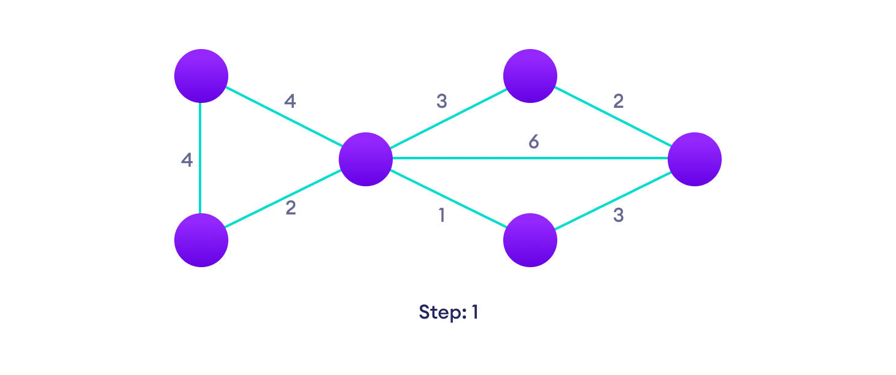Start with a weighted graph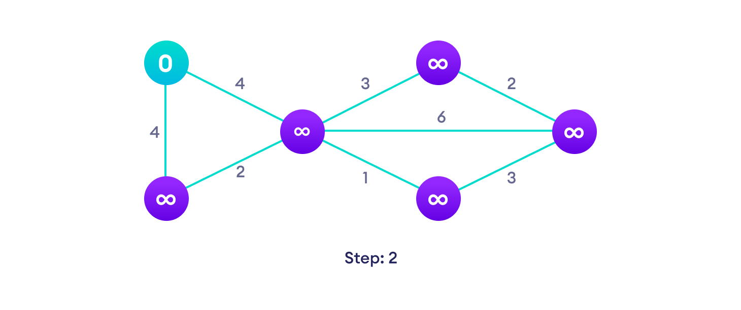Choose a starting vertex and assign infinity path values to all other devices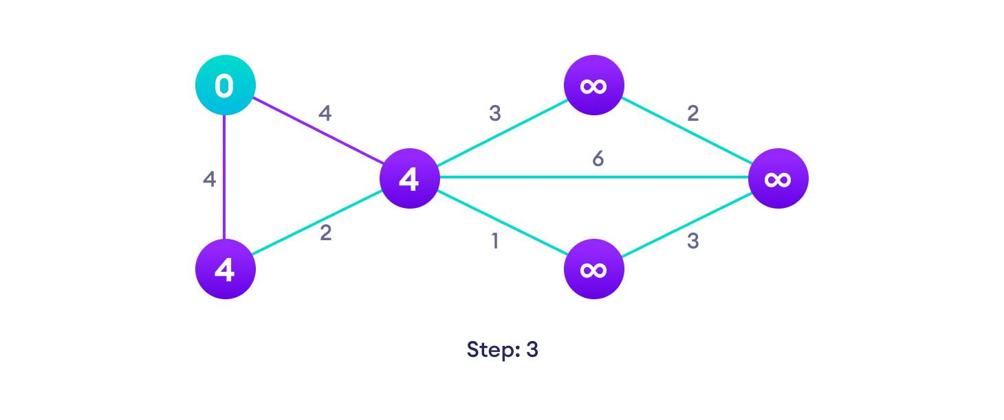Go to each vertex and update its path length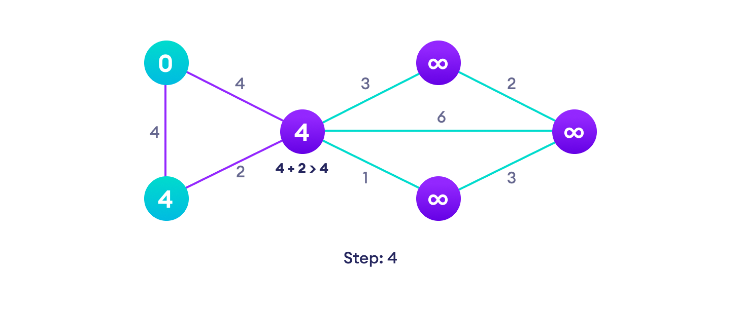If the path length of the adjacent vertex is lesser than new path length, don't update it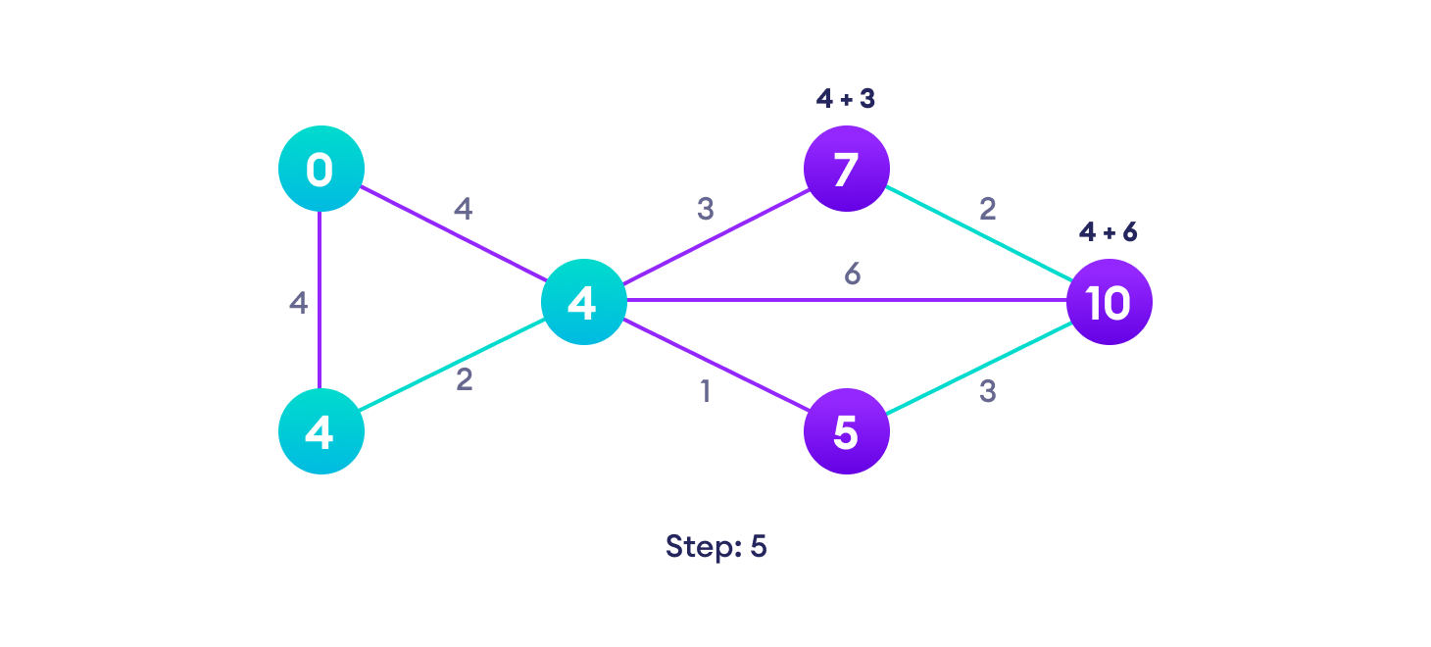Avoid updating path lengths of already visited vertices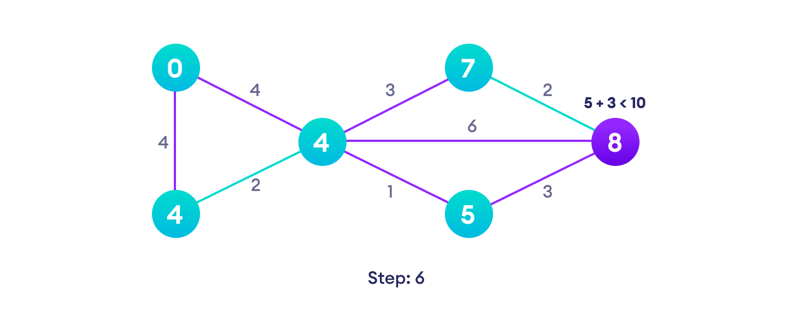After each iteration, we pick the unvisited vertex with the least path length. So we choose 5 before 7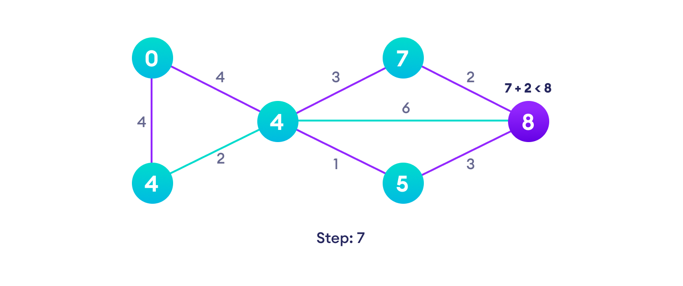Notice how the rightmost vertex has its path length updated twice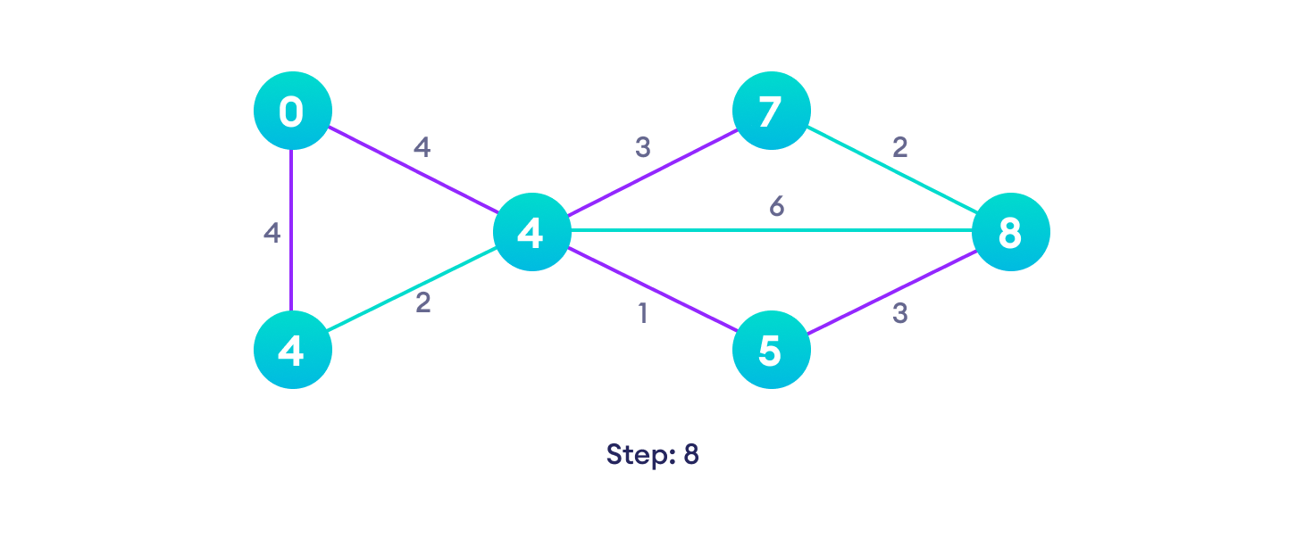Repeat until all the vertices have been visited

**Algorithm:**

Dijkstra(G,w,s)

Initialize_single_source(G,s)

S = Φ

Q = G.V

While(Q!= Φ)

u = Extract_min(Q)

S = S U {u}

For each vertex v of G Adj[u]

Relax(u,v,w)

Initialize_single_source(G,s)

For each vertex v of G.V

v.d = ∞

v. π = NIL

Relax(u,v,w)

If v.d > u.d + w(u,v)

v.d = u.d + w(u,v)

v. π = u

**Code:**  //dijkstra algo shortest distance from source

#include <stdio.h>

#include<stdbool.h>

#include <limits.h>

int minDistance(int dist[], bool sptSet[])

{

int min = INT_MAX, min_index;

for (int v = 0; v < 6; v++)

if (sptSet[v] == false && dist[v] <= min)

min = dist[v], min_index = v;

return min_index;

}

void dijkstra(int graph[6][6],int src){

int dist[6];

bool sptSet[6];

for (int i = 0; i < 6; i++)

{dist[i] = INT_MAX;

sptSet[i] = false;}

dist[src] = 0;

for (int count = 0; count < 5; count++) {

int u = minDistance(dist, sptSet);

sptSet[u] = true;

for (int v = 0; v < 6; v++)

if (!sptSet[v] && graph[u][v]

&& dist[u] != INT_MAX

&& dist[u] + graph[u][v] < dist[v])

dist[v] = dist[u] + graph[u][v];

}

printf("Vertex \t\t Distance from Source\n");

for (int i = 0; i < 6; i++)

printf("%d \t\t\t\t %d\n", i, dist[i]);

}

void main()

{

int graph[6][6]={{0,1,4,0,0,0},

{0,0,1,2,1,0},

{0,0,0,0,5,0},

{0,0,0,0,0,2},

{0,0,0,0,0,1},

{0,0,0,0,0,0}};

dijkstra(graph,0);

}

**Output:**

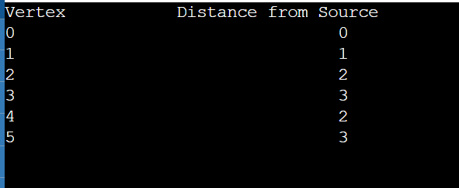

**Conclusion:** Thus we have implemented shortest path of each node from the source using Greedy Approach (Dijkstra’s Algorithm)